Governmental Body:  The City Council of Baxter, Iowa | Call In Information:  City Council Meeting – February 23rd, 2026, 6:00 PM (America/Chicago)  Please join my meeting from your computer, tablet or smartphone.  https://meet.goto.com/813335189  You can also dial in using your phone.  Access Code 813-335-189  United States: +1 (872) 240-3311
Date of Meeting:
Monday, February, 23rd 2026
Time of Meeting:
6:00 P.M.
Place of Meeting:
Baxter Council Chambers
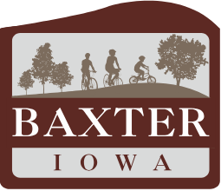

- Call to Order by Mayor Danny Kunkel

- Approval of the Agenda

Roll Call

Independent Investigation Report – Presentation and Recommendations

Council Discussion and Possible Action

- Public Comments - At this time, citizens may address the Council. Except in cases of legal emergency, the City Council cannot take formal action at the meeting but may ask City staff to research the matter or have it placed on a subsequent Agenda. To be heard, a citizen must be recognized by the chair and state their name and address. Speakers will be given three minutes to present their concerns. Comments and/or questions must be related to City policies or the provision of City services and shall not include derogatory comments about other individuals. Unless specifically called upon by the Mayor, no additional comments and/or questions will be addressed during the remaining meeting once the Public Comment portion has been closed.

- Adjournment

This notice is hereby given at the direction of the Mayor pursuant to Chapter 21.4, Code of Iowa, and the local rules of said governmental body.

AMERICANS WITH DISABILITIES ACT COMPLIANCE: IF THERE IS ANYONE WISHING TO ATTEND THE MEETING THAT MAY REQUIRE SPECIAL ASSISTANCE IN BEING ABLE TO PARTICIPATE IN THIS MEETING, PLEASE ADVISE CITY HALL OF YOUR NEEDS 48 HOURS BEFORE THE MEETING

